**Web ICP 4**

In this class we discussed on topics of JavaScript and jQuery

1.Hover image

I have added jquery cdn to the head section of the document.

So that I can make use of jquery in the script.js file

There are no much changes other than this in the html file.

In the script.js file when user hovers on any image then this method will be called – upDate()

We are passing the mouseover event to this method so that the image which is hovered will get referenced here.

Using jQuery getting the image id reference and then added the background image using css() method of jQuery.

This previewPic contains all the details of the hovered image like src, alt e.t.c

Similarly set the text to the image using text() method.

On mouseOut – undo() method will be called. And here we are resetting the image background and alt text as below.

**OUTPUT:**

When hovered on one of the image

When user removes hover from the image

**TASK 2: Github User Finder**

In this task a new XMLHttpRequest is created when user hits enter in the input text area which is having id “username”

Here is the html file

Here we have a container to set the layout for the entire page. There is a input text field inside an search element.

When user types something in this text field, a jQuery document.on method will be called. Here is the demo for this

After this when user hots enter button the program logic will enter if class. Here ASCII code for enter key is 13.

So the text that’s entered by the user will be stored in a variable username and then we are clearing the input text field.

With this user input as a parameter getGithubInfo() method will be called where there is a new ajax call getting created.

We can use XML HTTP request method, $.ajax method and even other third party plugins to make an asynchronous calls.

Here I have used XML HTTP request method for making an ajax call.

Xhttp.open opens a connection to the requested url and xhttp.send() sends the request.

After getting the user response successfully I have displayed the user information to the profile content.

In the html I have added a errormessage class so that when there is an error I will make use of this element ot display instead of profile.

Show() and hide() methods will add and remove elements from the DOM.

When the request status is not 200 then this noSuchUser() method will be called.

Here am displaying the error message and hiding the profile section.

OUTPUT:

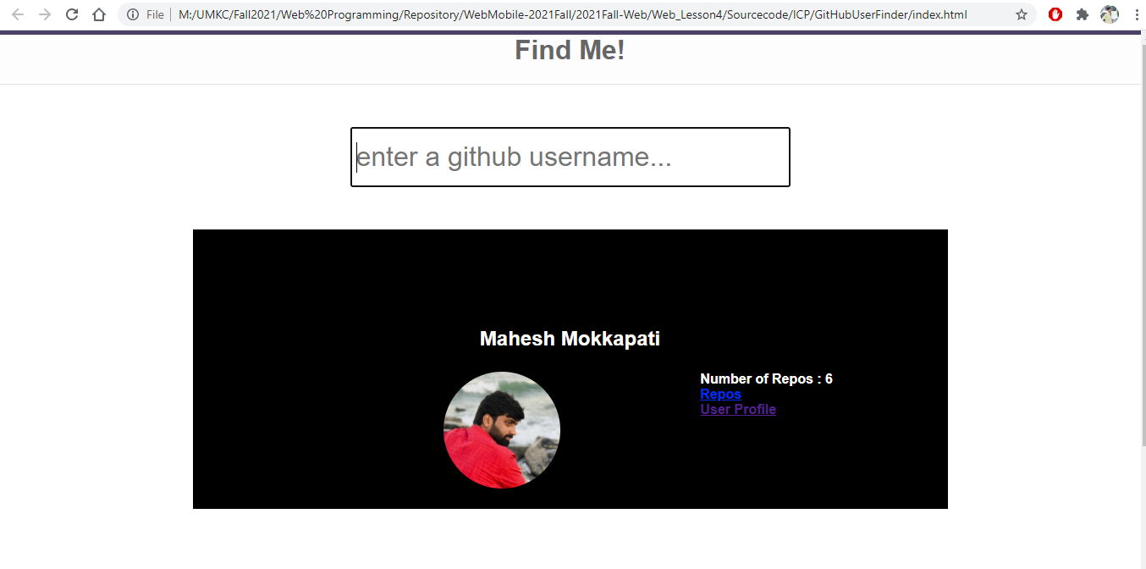

When user inputs anything into the text field again profile section is removed from the DOM.

